Report by: 1409046  
Role: Level Design & Artist liaison

Game Version: Latest – with Menus  
Date Reported: 02/05/2016

QA Status: Passed

Severity: Minor

Priority: Low

Test Introduction:

The purpose of this test was to check that the ship stayed oriented after a small collision with an obstacle, to test this I ran the ship into a wall just as it was passing, so it clipped the edge of the obstacle

Expected outcome:

I expected the ship to continue on its path without being knocked off it orientation

Actual outcome:

When I ran the sip into the edge of the obstacle it started to shake on it axis and had a slight effect on the movement from side to side.

Screenshot of the bug:

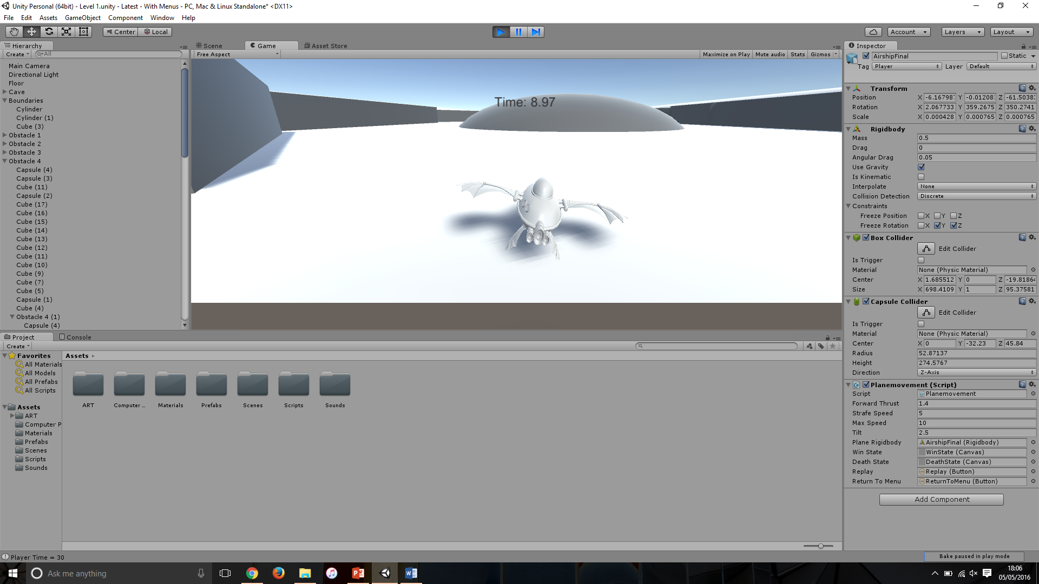

Image showing the ship ‘shaking’ when moving along track

Potential cause:

A potential cause for this bug could be written into the player movement script, as the shaking occurs when it is speeding up again after a decrease in speed.

Something else that could be causing this could be that the model is over spilling from the collider, causing the rocking motion as it moves from one tail part to another.

Another potential cause for this bug could be the fact that the cylinder collider that the ship is using for movement is too narrow, meaning it will rock forward and backward across the surface of the cylinder.

Suggested Fix:

To fix this bug I increased the diameter of the cylinder collider that the ship is sitting on.